
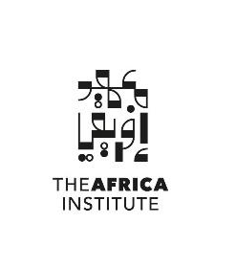
For Immediate Release
Exploring the Future of Coastal Ecologies and Economies: The Africa Institute Hosts Symposium on Indian Ocean Connections in Sharjah
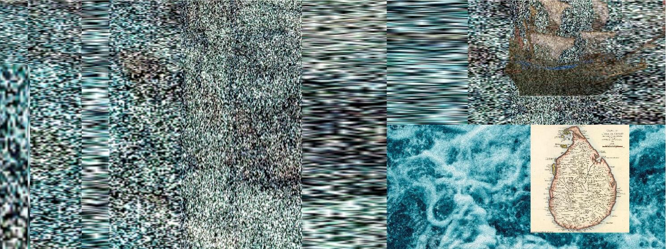
Concluding Symposium of "Thinking the Archipelago: Africa’s Indian Ocean Islands" Convenes Leading Scholars to Tackle Climate, Heritage, and Development Issues
Image 1: The main visual for the symposium is Straddling Ocean and Sky (2021–2022) by Sri Lankan interdisciplinary artist Pushpakanthan Pakkiyarajah. The artwork examines the resilience and fragility of nature as a source of healing from trauma, aligning with the symposium's exploration of interconnected ecologies and histories within the Indian Ocean rim.

November 14, 2024, Sharjah – UAE: The Africa Institute, Global Studies University (GSU) in Sharjah, UAE, invites scholars, policymakers, and climate activists to a symposium that will conclude the Thinking the Archipelago: Africa’s Indian Ocean Islands season, running from December 6-8, 2024.
This three-day event will open with welcome remarks by Salah Hassan, Chancellor of GSU and Dean of The Africa Institute, setting the stage for in-depth discussions on ecological, cultural, and economic connections across the Indian Ocean rim. This symposium is supported by the Social Science Research Council’s (SSRC) Transregional Collaboratory on the Indian Ocean, an initiative to catalyze new research into the intersections of social and environmental change in and across Indian Ocean countries.
The Country-focused Season is a cornerstone of The Africa Institute’s mission to explore Africa’s complex history and engage with contemporary issues that impact its diverse regions. This year marks the third edition of Thinking the Archipelago: Africa’s Indian Ocean Islands, which began in December 2022. Over the past two years, The Africa Institute has hosted symposia in Sharjah and Zanzibar, bringing together leading scholars, artists, and activists to create a growing body of original scholarship. Topics explored have included migration, race and slavery, and the role of art in shaping cultural exchanges across the Indian Ocean world.
This final symposium, Intertwined Ecologies and Interconnected Histories: The Indian Ocean Rim, will address critical challenges facing the Indian Ocean’s coastal communities, including climate resilience, environmental adaptation, and socio-economic changes. Through collaborative discussions, the event aims to foster innovative solutions and new insights on sustainable development.
Esteemed scholars convening the symposium include Jeremy Prestholdt, Professor of History at the University of California, San Diego; Rogaia Mustafa Abusharaf, Professor of Anthropology at Georgetown University in Qatar; and Uday Chandra, Assistant Professor of Government at Georgetown University in Qatar. The event will bring together an international cohort of over 20 scholars, environmental policymakers, cultural historians, and climate activists. The symposium will feature a selection of keynote addresses and panels, including:
- Keynote address: Intertwined Ecologies and Biotic Borders: Plants, Politics and Print in the Indian Ocean World by Isabel Hofmeyr – Professor Emeritus, University of the Witwatersrand, Johannesburg, South Africa
- Facing Climate Change: Livelihoods and Adaptation
Examining the adaptation strategies of coastal communities in response to climate-driven transformations.
- Tides of Change: Interactions in the Indian Ocean World
Discussing the impact of human-marine interactions on cultural exchanges in the Indian Ocean region.
- Tributaries: Ecology, Economy, and Society in Indian Ocean Histories
A historical exploration of economic activities and ecological challenges that continue to shape the region today.
- Recording Environmental Change
Presenting innovative methods for documenting environmental shifts and the cultural memory of affected communities.
- Bridges: From Paradise Gardens to Offshore Winds in the Indian Ocean
Addressing sustainable practices in heritage conservation and environmental planning for balanced development.
The symposium is open to the public, with pre-registration encouraged. Arabic interpretation will be available on-site, and a livestream will be provided for remote attendees.
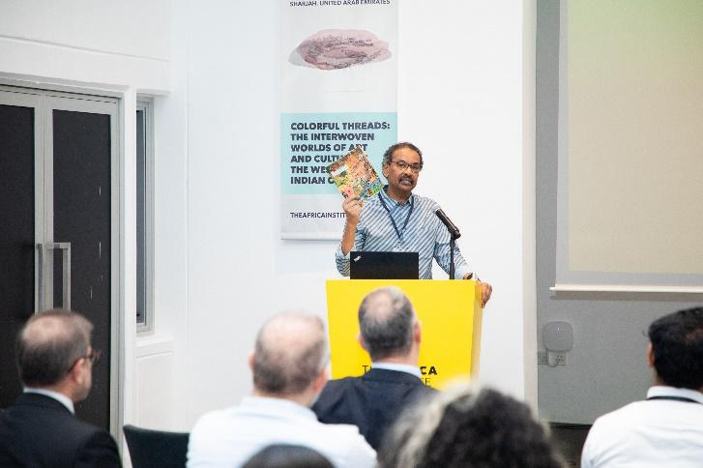
The Africa Institute’s Monsoon: Journal of the Indian Ocean Rim, launched alongside the opening of this season, provides a platform for cutting-edge research on the cultural, historical, and ecological dimensions of the Indian Ocean region. The journal focuses on advancing knowledge of the interconnected societies of the Indian Ocean, with particular attention to African and Gulf perspectives that have been underrepresented in existing literature. Monsoon is available through Duke University Press and can be purchased through The Africa Institute's bookshop.
Image 2: Salah M. Hassan, Chancellor of GSU and Dean of The Africa Institute, announces the release of Monsoon: Journal of the Indian Ocean Rim, a groundbreaking publication exploring the cultural, historical, and ecological dimensions of the Indian Ocean region.

As the final event of the Thinking the Archipelago: Africa’s Indian Ocean Islands series, this symposium aims to inspire new academic collaborations and deepen the understanding of the interconnected histories and ecologies of the Indian Ocean region.
In alignment with The Africa Institute’s mission, the two-year Master of Arts in Global African Studies is offered. This interdisciplinary academic program provides students with an in-depth understanding of African history, culture, and global connections, equipping them to engage with contemporary issues shaping the African continent and its diasporas. Full scholarships are available to support eligible students in their academic pursuits.
***

About Global Studies University (GSU) and The Africa Institute
Based in Sharjah, UAE, The Africa Institute is a non-profit higher education academic entity dedicated to advancing the study, research, and documentation of Africa and its diaspora, with a focus on the humanities and social sciences. It operates as a center of research and documentation, and a postgraduate studies institution, offering master’s and Ph.D. programs as well as certificates in African Languages and Translation. The Africa Institute aims to be a center of excellence to train a new generation of critical thinkers in African and African diaspora studies. In 2023, The Africa Institute became part of the newly established Global Studies University (GSU), integrated into its network of semi-independent and interdisciplinary institutes, with each focusing on different regions worldwide. These institutes emphasize postgraduate studies, research, and documentation of the histories, cultures, and peoples of various global regions. The next entity to be officially established in 2025 is The Asia Institute. Additionally, preparations are underway to launch other institutes focusing on Oceania, Europe, and the Americas in the coming years. Led by Hoor Al Qasimi, President of GSU, and Salah M. Hassan, Chancellor of GSU and Dean of The Africa Institute. For more information, visit theafricainstitute.org.
For additional information, interview requests, or press images, please contact:

Megna Kalvani, Communications & Outreach Manager:
T: 971 6 5112417 | M: +971 50 241 0577 | megna.kalvani@theafricainstitute.org

Aisha Al Hammadi, Communications & Outreach Coordinator
T: + 971 6 5112415 | M: +971 56 3739520 | aisha.alhammadi@theafricainstitute.org

