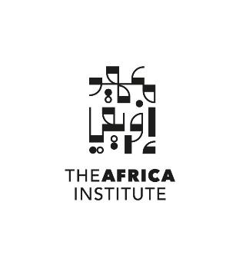
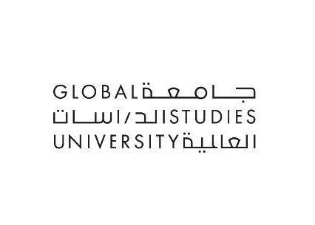

For Immediate Release

Global Experts to Explore New Directions in African Political Economy at The Africa Institute, Honoring Thandika Mkandawire

Three-day conference in Sharjah to tackle emerging global challenges, featuring leading scholars and policymakers in African development.

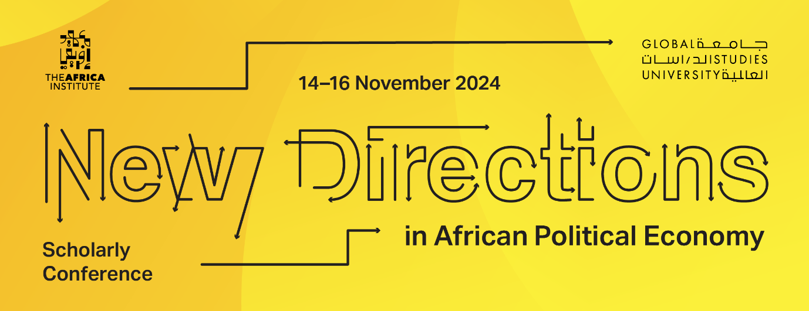

October 22, 2024, Sharjah, UAE – The Africa Institute, Global Studies University (GSU) in Sharjah, will host an international conference from November 14-16, 2024, titled New Directions in African Political Economy. This three-day event is set to engage global scholars in critical discussions on the future of African political economy, centered on the intellectual legacy of the late Professor Thandika Mkandawire, one of Africa's most influential political economists.

The conference comes at a pivotal moment for Africa as the continent's role in the global economy continues to evolve amid new challenges. It will offer a unique platform to reflect on Mkandawire's groundbreaking scholarship, which reshaped conventional understandings of African development, emphasizing African agency and dignity. His work remains essential for scholars, policymakers, and institutions navigating Africa's complex socio-economic landscape.

More than 25 distinguished speakers from leading institutions across UAE, Africa, Europe, and North America will gather for keynote addresses, panel discussions, and dialogues. The event will feature participants from renowned institutions such as Cornell University, Stellenbosch University, CODESRIA, University of South Africa, Howard University, and the International Development Economics Associates.

The conference will open with welcome remarks from Hoor Al Qasimi, President of GSU, and Professor Salah M. Hassan, Chancellor of GSU and Dean of The Africa Institute (GSU), followed by conference convenor, Grieve Chelwa, Associate Professor of Political Economy at The Africa Institute (GSU).

"Thandika Mkandawire was more than just a first-rate scholar; he fundamentally reshaped how we understand African political economy. His approach was revolutionary because he insisted on examining Africa's trajectory from a position of dignity, rather than deficit. What makes this conference particularly special is its intergenerational nature – we're bringing together Mkandawire's contemporaries and friends alongside mid-career and emerging scholars, all united in advancing his intellectual legacy. By convening such a diverse group of rigorous thinkers in Sharjah, we're not just celebrating Thandika's contributions but actively charting new directions for African political economy in the 21st century," said Dr. Grieve Chelwa.

Conference Highlights:
- Paul Tiyambe Zeleza, Senior Advisor for Strategic Initiatives at Howard University, presenting the opening keynote on African intellectual decolonization
- Abdalla Hamdok, Executive Chairman of the Center for Africa's Development and Investment (CADI), presenting a dialogue on building progressive scholarly communities in Africa
- Vijay Prashad, Executive Director of Tricontinental: Institute for Social Research, presenting the second keynote, “Can We Build Scholarship for Our People? Walking by the Durban Beach with Thandika Mkandawire in 2001,” on revitalizing intellectual production in the Global South
- Pumla Gobodo-Madikizela, Professor and South African Research Chair in Studies in Historical Trauma and Transformation, Stellenbosch University, presenting the closing keynote on historical trauma and knowledge production
- Godwin Murunga, Executive Secretary of CODESRIA, presenting on Thandika Mkandawire’s approach to grounded methodologies
- Book Launch: Re-envisioning the African and American Academies (Dakar: CODESRIA Press, 2024) by Paul Tiyambe Zeleza — a vital exploration of higher education dynamics amid global challenges.

Panel Discussions: The conference will feature five-panel discussions chaired by faculty members of The Africa Institute, focusing on critical themes in African political economy: Social Policy and Development; Development and the Developmental State; Intellectual Thought; Globalization and Development; and Agriculture, Land, and Structural Transformation in Africa. These discussions are expected to produce a series of policy and scholarly papers that could influence African economic strategies in the coming years.

The conference is open to the public, with particular relevance for students, scholars, policymakers, and individuals engaged with African development, global political economy, and international affairs.

The conference will be conducted in English, with Arabic interpretation provided to ensure accessibility for a wider audience. For those unable to attend in person, the event will be livestreamed on The Africa Institute’s YouTube channel. For registration and to view the full conference program, visit: theafricainstitute.org

About The Africa Institute, Global Studies University (GSU), Sharjah
Based in Sharjah, UAE, The Africa Institute is a higher education academic entity dedicated to advancing the study, research, and documentation of Africa and its diaspora, with a focus on the humanities and social sciences. It operates as a center of research and documentation, and a postgraduate studies institution, offering master’s and Ph.D. programs as well as diplomas in African Languages and Translation. The Africa Institute aims to be a center of excellence to train a new generation of critical thinkers in African and African diaspora studies. In 2023, The Africa Institute became part of the newly established Global Studies University (GSU), integrated into its network of semi-independent and interdisciplinary institutes, with each focusing on different regions worldwide. These institutes emphasize postgraduate studies, research, and documentation of the histories, cultures, and peoples of various global regions. The next entity to be officially established in 2024 is The Asia Institute. Additionally, preparations are underway to launch other institutes focusing on Oceania, Europe, and the Americas in the coming years. The Africa Institute is led by Hoor Al Qasimi, President of Global Studies University, and Salah M. Hassan, Dean of The Africa Institute and Chancellor of Global Studies University. For more information, visit theafricainstitute.org.

About the Late Thandika Mkandawire
The late Thandika Mkandawire (10 October 1940 – 27 March 2020) was a development economist, former refugee, and the inaugural Chair in African Development at LSE. He was a vocal critic of the predominant neo-liberal development theories of the 1990s, arguing that they lacked an African perspective. Born in Zimbabwe, Mkandawire was raised in Zambia and Malawi. He became involved in Malawi’s independence movement, initially protesting on the streets and later through his journalism. He moved to the United States to study, but in 1965, during a visit to Ecuador, the Malawian government revoked his passport. This left him persona non grata until he was granted political asylum and eventually gained citizenship in Sweden. He did not return to Malawi until 1994, after 30 years in exile. In his academic career, Mkandawire was a founding member of the Zimbabwe Institute of Development Studies and The Council for the Development of Social Science Research in Africa (CODESRIA) in Dakar, Senegal. He later served as director of the UN Research Institute for Social Development in Geneva before joining LSE as the Chair in African Development. His final academic position was as the Olof Palme Professor for Peace at the Swedish Institute for Future Studies. Thandika Mkandawire passed away in Stockholm on 27 March 2020.

For additional information, interview requests, or press images, please contact:

Megna Kalvani, Communications & Outreach Manager:
T: 971 6 5112417 | M: +971 50 241 0577 | megna.kalvani@theafricainstitute.org

Aisha Al Hammadi, Communications & Outreach Coordinator
T: + 971 6 5112415 | M: +971 56 3739520 | aisha.alhammadi@theafricainstitute.org

