For Immediate Release
Book Launch: Ethiopia: Modern Nation – Ancient Roots at The Africa Institute, Global Studies University
Reflections with the Co-Editors on Ethiopia’s Cultural and Political Influence – A New Publication by Iwalewa Books and The Africa Institute

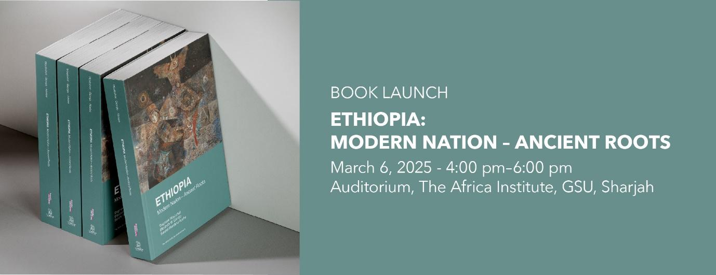

Sharjah, UAE – March 6, 2025 – The Africa Institute, Global Studies University, successfully launched Ethiopia: Modern Nation – Ancient Roots, the latest publication edited by Professors Dagmawi Woubshet, Elizabeth W. Giorgis, and Surafel Wondimu Abebe in collaboration with Iwalewa Books, on March 6, 2025.

The book examines Ethiopia’s status as the only African nation never colonized, presenting a nuanced analysis of its role in African modernity.

The event, hosted at The Africa Institute, opened with welcome remarks by Salah M. Hassan, Chancellor of Global Studies University and Dean of The Africa Institute. He described the publication as "a direct outcome of the inaugural Country-Focused Season on Ethiopia (2019–2020), which brought together scholars and artists to examine Ethiopia’s historical and cultural legacies. This book extends those discussions, offering critical perspectives on Ethiopia’s role in African modernity."

A flagship program of The Africa Institute, the Country-Focused Season is a specially curated annual initiative that explores one African country or African diaspora community through a range of scholarly and public programs.

The launch featured introductory remarks and a conversation among the three editors and Dr. Nadine Siegert, publisher at Iwalewa Books. All three co-editors also served as co-conveners of the Ethiopia Country-Focused Season (2019–2020), which shared the same title as the publication.

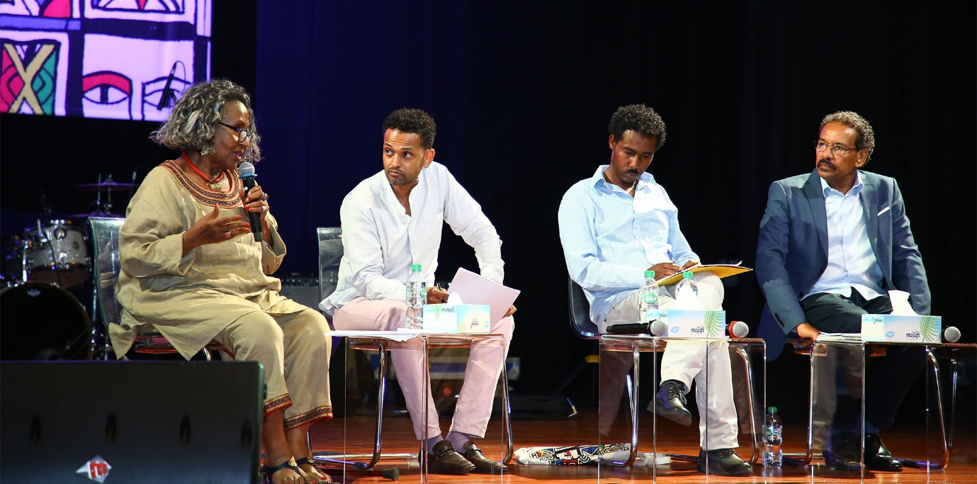
From the Archives: Country-Focused Season 2019–2020 – Ethiopia: Modern Nation, Ancient Roots
(L-R) Elizabeth W. Giorgis, Dagmawi Woubshet, Surafel Wondimu Abebe, and Salah M. Hassan.

Reflecting on the book’s significance, Dagmawi Woubshet, Edmund J. and Louise W. Kahn Endowed Term Associate Professor of English, University of Pennsylvania said, "This publication sheds light on Ethiopia’s modernity while challenging common perceptions of African historical narratives. It is both a scholarly intervention and a tribute to Ethiopia’s rich intellectual traditions."

Professor Elizabeth W. Giorgis, Chair of the Department of Humanities and Professor of Art History at The Africa Institute, said, "By weaving together literary, visual, and performance studies, the book presents an interdisciplinary exploration of Ethiopia’s cultural identity, offering fresh perspectives on its historical and contemporary relevance."

Professor Surafel Wondimu Abebe, Assistant Professor of Performance Studies at The Africa Institute, added, "Ethiopia’s history and artistic traditions demand critical rethinking and multidimensional approach, and this publication brings together diverse voices to examine its multifaceted legacies in the present."

Published by Iwalewa Books, based in Johannesburg, South Africa, the book is structured across five thematic sections, exploring Ethiopia’s literary, visual, and performing arts, migration patterns, and historical transformations. It provides insights into how the country’s unique position has shaped its cultural identity and broader African political and artistic movements.

The launch also featured a conversation with the editors and Dr. Sehin Teferra, founder of the Setaweet Movement and a contributing author. Their discussion explored key themes of the book, including Ethiopian women’s experiences, cultural resilience, and historical transformations, providing further insight into the intersections of gender, identity, and artistic expression in Ethiopia.

The publication is now available at The Africa Institute’s on-campus bookshop, Meroë Bookshop, and online through Iwalewa Books. It promises to be a significant addition to scholarly works on African history and cultural studies.

Led by Sheikha Hoor Al Qasimi, President of Global Studies University, The Africa Institute advances African studies through interdisciplinary research, graduate programs (Master’s in Global African Studies, Ph.D. in Global Studies, ), African language certifications, and public initiatives that connect scholars, students, and the wider public. Visit their website to learn more: theafricainstitute.org or gsu.ac.ae.

About the Book: Ethiopia: Modern Nation – Ancient Roots

There is much in Ethiopia’s cultural and political identity that contemporary audiences will find inspiring. For instance, while the colonial thesis argues that Africa is singularity the invention of European colonialism, the non-colonial thesis in Ethiopian scholarship sees Ethiopia through the lens of exceptionalism, that Ethiopia, which was never colonized, is in rather than of Africa. If African modernity and modernism are intimately linked with colonialism, certainly Ethiopia’s inimitable historical condition merits fresh lines of inquiry to understand how Ethiopian negotiated their “independent” status quo through and against colonial arrangements that shaped the historical, cultural, and material realities of their African counterparts. One of this book’s central contributions is, therefore, its conceptualization of how Ethiopia’s singular colonial history can be analyzed in relation to the political thought that shaped African colonial history. Ethiopia’s supposed singularity, as it particularly pertains to its modern history, cannot be conceived outside the broader colonial legacy and the complexity of meaning and making. Read more.

Participant Biographies

Editors
- Dagmawi Woubshet is the Edmund J. and Louise W. Kahn Endowed Term Associate Professor of English at the University of Pennsylvania. A scholar in African American and African studies, he has contributed significantly to the academic understanding of the intersection of race and culture. He is currently a resident fellow of the Toni Morrison Senior Fellowship in African Literature and Cultural Studies at The Africa Institute, GSU. Read more.
- Elizabeth W. Giorgis is the Chair of the Department of Humanities and Professor of Art History, Theory, and Criticism at The Africa Institute, GSU, Sharjah. Her expertise in Ethiopian visual modernism and global African studies has made her a leading voice in the field. Read more.
- Surafel Wondimu Abebe is an Assistant Professor of Performance Studies and Theory at The Africa Institute, GSU, Sharjah. His interdisciplinary approach to cultural politics and performance theory has shaped his work on the complexities of identity and representation in contemporary African contexts. Read more.

Participant Biographies
- Salah M. Hassan, Chancellor of Global Studies University and Dean of The Africa Institute. Read more.
- Dr. Nadine Siegert is a writer, curator, publisher, and currently the Head of “Culture and Development” (Goethe-Institute in Johannesburg). From 2011 to 2019, she was the Deputy Director of Iwalewahaus (University of Bayreuth) and sits on the board of Asele Institute and ACASA. Siegert also runs the publishing house Iwalewa Books.
- Dr. Sehin Teferra is the founder of the Setaweet Movement, an Ethiopian feminist network advocating for gender equality and justice. She holds a Ph.D. in gender studies from SOAS, University of London, and has authored the chapter “Feminist Parenting: Perspectives from Africa and Beyond.” Teferra also represents Setaweet on Ethiopia’s Presidential Advisory Board and is part of the Destiny Ethiopia initiative.
- Iwalewa Books, based in Johannesburg, Lagos, and Frankfurt, is a renowned publisher specializing in works that focus on African and postcolonial studies. The publisher’s commitment to highlighting voices from the Global South has made it a key player in contemporary academic publishing. Read more.
- Setaweet (meaning ‘of woman’) in Amharic is a contemporary feminist movement founded in July 2014. They are a home-grown, grassroots, and uniquely Ethiopian collective of women and men who are dedicated to the empowerment and liberation of all Ethiopian women and men. Read more.
About The Africa Institute, Global Studies University (GSU), Sharjah
Based in Sharjah, UAE, The Africa Institute is a higher education academic entity dedicated to advancing the study, research, and documentation of Africa and its diaspora, with a focus on the humanities and social sciences. It operates as a center of research and documentation, and a postgraduate studies institution, offering master’s and Ph.D. programs as well as diplomas in African Languages and Translation. The Africa Institute aims to be a center of excellence to train a new generation of critical thinkers in African and African diaspora studies. In 2023, The Africa Institute became part of the newly established Global Studies University (GSU), integrated into its network of semi-independent and interdisciplinary institutes, with each focusing on different regions worldwide. These institutes emphasize postgraduate studies, research, and documentation of the histories, cultures, and peoples of various global regions. Additionally, preparations are underway to launch other institutes focusing on Oceania, Europe, and the Americas in the coming years. The Africa Institute is led by Hoor Al Qasimi, President of Global Studies University, and Salah M. Hassan, Dean of The Africa Institute and Chancellor of Global Studies University. For more information, visit theafricainstitute.org.

For additional information, interview requests, or press images, please contact:

Megna Kalvani, Communications & Outreach Manager:
T: 971 6 5112417 | M: +971 50 241 0577 | megna.kalvani@theafricainstitute.org

Aisha Al Hammadi, Communications & Outreach Coordinator
T: + 971 6 5112415 | M: +971 56 3739520 | aisha.alhammadi@theafricainstitute.org

